

RESTRICTION ON USE, DUPLICATION, OR DICLOSURE OF PROPRIETARY INFORMATION

This document contains proprietary information which is the sole property of ELTA System Ltd. This document is submitted to the recipient for his use only. By receiving this document the recipient undertakes not to duplicate the document or to disclose in part of or the hole of, any of information contained herein to ant third party without receiving beforehand, written permission from the submitting company

February 4, 2021



TRADES Tool

Installation Guid



Table of Contents

1. Introduction 3

1.1. Purpose 3

1.2. Identification 3

1.3. Reference information 3

1.4. Contact Information 3

2. Installation Manual 4

2.1. Pre-requisites 4

2.2. Download 4

2.3. Install procedure 4

3. Start modeling 5

3.1. Create new project 5

4. Modeling with TRADES Tool 8

Introduction

## Purpose

TRADES is the home of the threat and risk assessment. The tool is model-based TRA for design of systems.

With TRADES, you can create your system’s digital twin and assess the system risk level through the system life cycle.

In this guide, you will find how to download, install and start using the TRADES tool.

## Identification

This guide is for TRADES 2.5.0 beta.

## Reference information

All relevant documents, versions, and source-code can be found on the TRADES GIT.

## Contact Information

Any question or request that is not in the documentation can mail to tcohen3@Elta.co.il.

Installation Manual

## Pre-requisites

There are no pre-requisites for the installation.

## Download

TRADES tool version 2.5.0 beta is the latest and recommended version of the tool.

The version can be download from the [releases section](https://github.com/IAI-Cyber/TRADES/releases) on the GIT page.

On the assets tab, chose the relevant and download the zip file.

## Install procedure

Unzip the downloaded file (better with 7zip, but not mandatory).

Start modeling

## Create new project

1. On the product, folder click on trades.exe.
2. Workspace location selection will be open. The workspace is where the data of a specific project will be saved.

Browse the location and click “Launch”.

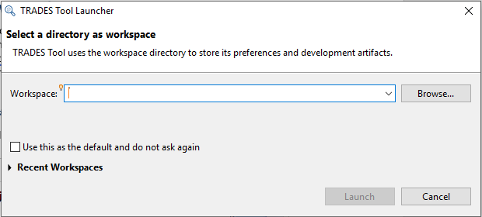

Figure 1: Select a directory as a workspace

1. TRADES main screen display

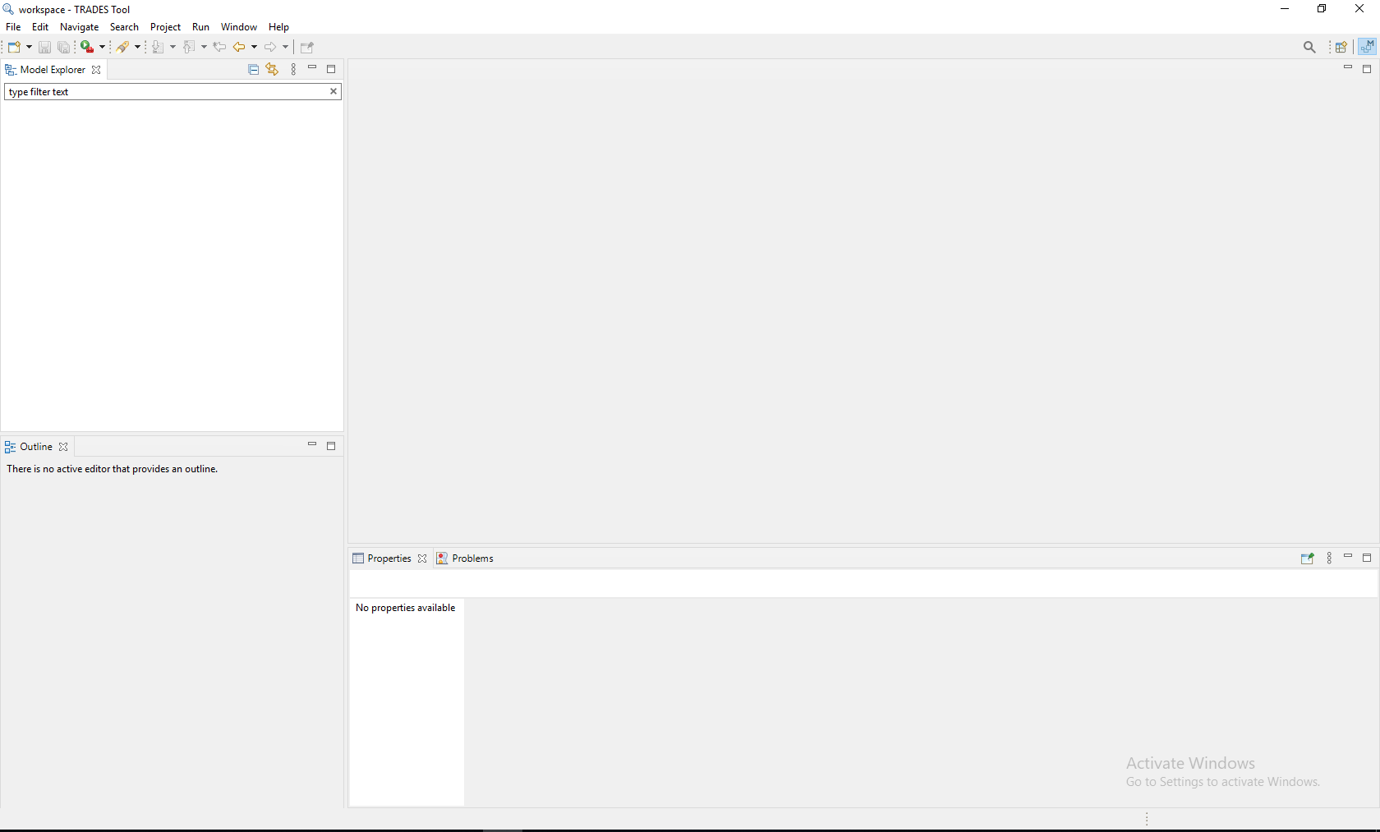

Figure 2: TRADES main screen

1. Right-click on the model explorer to create a new TRADE project.

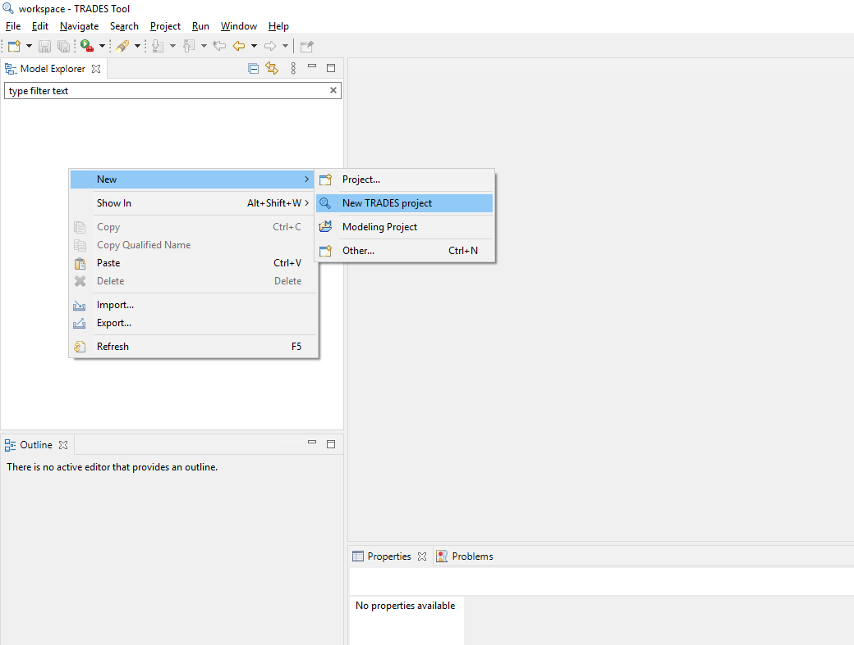

Figure 3: Creation of a new TRADES project

1. Enter the project name and click “Finish”.

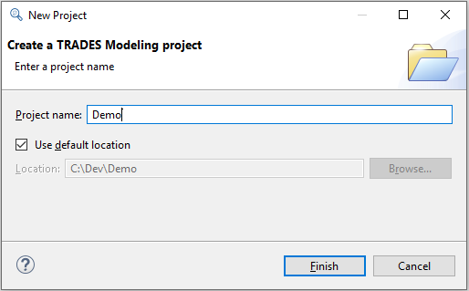

Figure 4: Set new project name

1. The new project should be available in the “Model Explorer” window section.

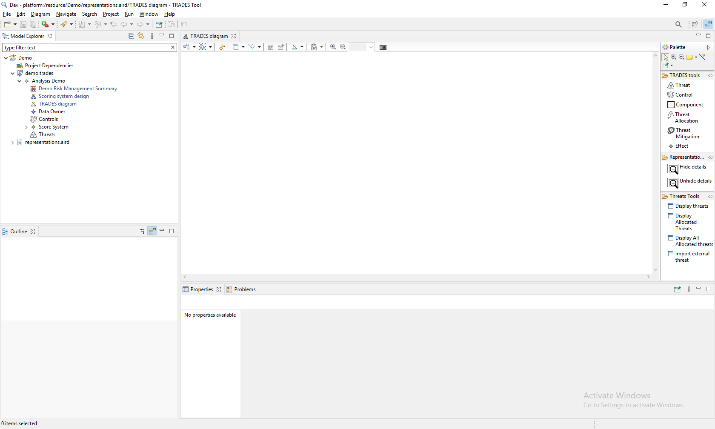

Figure 5: TRADES model ready for modeling

You are now ready to use TRADES.

Modeling with TRADES Tool

Please see the [presentation available in the TRADES Tool repository](https://github.com/IAI-Cyber/TRADES/blob/master/TRA%20with%20TRADES%20Tool%20English.pptx) for a detailed, step by step introduction to modeling with TRADES Tool.